Title: Compa Framework Watchdog for BMW ACSM5
Purpose : Program should sense that the test has been stopped and realize the actual progress has been made before the collision and restart it from the correct point.
Approach: Due to the Internal AD-Hoc Frameworks closed property there is no any API to use. So GUI Automation is required with a mix of Picture Recoginiton.

Project BMW Airbag | Author
Project name: BMW ACSM5 | Name: David Szurovecz
DG number: D4-271599 | Segment / Dept.: CES

Distribution (persons or teams to be informed)
Name/Team: | Role: | Name: | Role:

Document Release
by review (without further approval)
by review and approval (approver(s) below if applicable)
Name: | Dept.: | Date: | Signature or ESign reference

Document History
Version | Maturity | Date | Author, Department | Main Changes (e.g. CR number)
0.2 |  | 2016-05-03 | David Szurovecz, CES-HCT | Flashing ECU Chapter

Table of Content
1 Requirements and Design 4
1.1 Core Requirements: 4
1.1.1 Detect any type of Compa Framework collision during Testing. 4
1.1.2 Determine the Test completeness rate. Create a new Testlist. 5
1.1.3 Setup the Framework and execute the tests by running the testlist. 5
1.2 Architecture Overview: 5
1.3 Module overview 6
2 Methodology & Modules 7
2.1 Template matching 7
2.1.1 OpenCV 7
2.1.2 Numpy 7
2.2 Control Human Peripherials 8
2.2.1 Get the test completeness status from the Report 8
2.3 Future Development Ideas 8
3 Improvements 9
3.1 New Features in Revision 1.1: 9
3.1.1 Develop GUI 9
3.1.2 Develop better FAIL SAFE Function for Human Control 9
3.1.3 Develop more detailed logger with the following attributes: Cause of Freeze, Status Percent, DTC-s of failed testcases. 9
3.1.4 Instrument Initialization should be done by writing a batch script with parameters 10
3.1.5 Handle PyAutoGUI typewriter bug 10
3.1.6 Rework it to work without problems with ISC & Compa Framework 10
3.1.7 Create Executable 10
3.1.8 Make it Fully Portable and Configurable 10
3.2 Not Implemented but planned features 10
3.2.1 Detect If Test has been completed and rerun the Failed Test cases 10
3.2.2 Develop more smart picture recognition 11
3.3 Not Planned but Implemented features 11
3.3.1 Handle Exceptions Object Reference not set to an instance of object 11
3.3.2 Remove Hard coded strings : 12

Requirements and Design

Core Requirements:

1. Detect any type of Compa Framework collision during Testing.
2. Determine the Test completeness and create a new testlist what contains the not completed tests.
3. Setup the Framework and execute the tests by running the testlist.

Detect any type of Compa Framework collision during Testing.

A Watchdog Timer Cycles through every 5 seconds with a polling technique and checks if the Framework stops.

There is three types of Freezes:
- The CoFW Just closing without any error message. And the Process also terminated.
- The CoFW Throwing an error message (Compa Framework stopped working ) but the process still alive. Tests has been terminated.
- The CoFW Throwing an error message (object Reference not set to an instance of an object) The Process is alive and tests is running. This is the worst All the test results will be failed. Restarting Framework solve the problem.
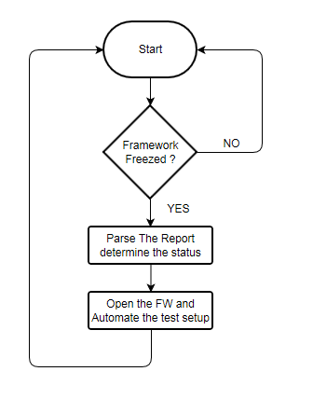
Figure 1. The Process of Program Flow

Determine the Test completeness rate. Create a new Testlist.

Before Reopening the Framework the tool is parsing the report to determine where the program has been collapsed. Afterwards it creates a testlist.

Setup the Framework and execute the tests by running the testlist.
The program will Start CoFW and Opening the Required Instruments Channels.
CAN1,CAN2,FlexRay1,FlexRay2,Colibri,PS1 and Opening the Testlist and Run the Test.

Approach: Take a screenshot from the desktop and match template with the requred image.

IMPORTANT: If the Windows lock screen active the code not works. Thats why the tests Every X seconds pushing the Num Lock button to prevent lock screen.

Architecture Overview:
To complete this task the SW should contain three main Software modules. Each of these modules has their own specified responsibility. There are additional modules what is not necessary but it’s nice to have like: Logger. See the basic architecture picture attached below.
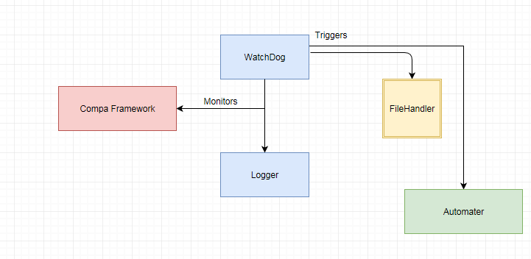
Figure 2. The basic architecture of System.

Module overview
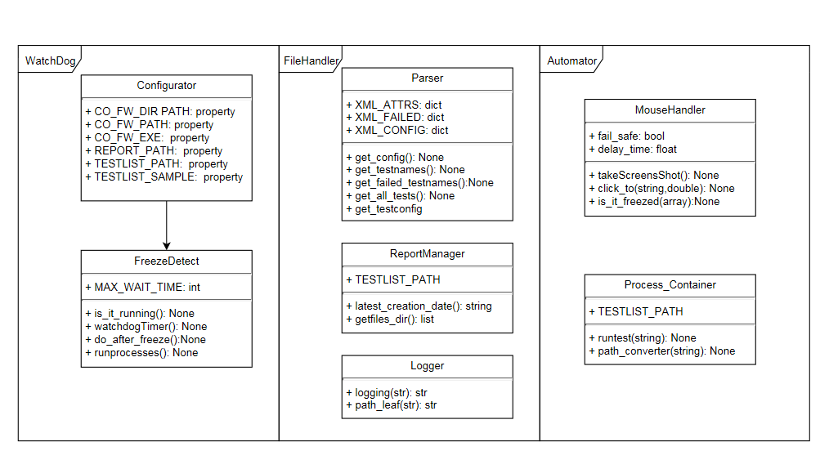

Methodology & Modules

In this Chapter the required modules and techniques will be introduced. Due the closed property of Compa Framework Controlling via API is not possible. So the Automation has been controlled by template matcing template. This is useful because working with fix coordinates cause a lot of problem if user moving the windows.

Template matching
Template matching is a technique for finding areas of an image that are similar to a patch (template).
Its application may be robotics or manufacturing. However there many ways of template matching but the general approach before to process the image and transform it to number arrays see the picture below.

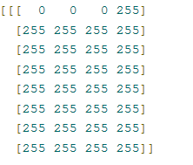
Figure 3. Matrix Array of a Pixel

All of the data is the image, each matrix block is a row of data, and each element within that is the pixel values in RGB-A (Red Green Blue Alpha). If the Transform has been done OpenCV can compare the results between two images. OpenCV provides function named „matchTemplate“ to find patterns. There are 6 algorithms are available to choose the best one is depends on the characteristics of the picture. For my purpose the best one was TM_CCOEFF_NORMED. see the picture below for he differential equation of the algorithm. In this subchapter the third party libraries will be introduce shortly.

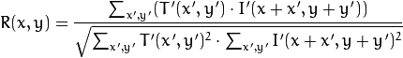
Figure 4. Differential Equation of TM_CCOEFF_NORMED

OpenCV
OpenCV (Open Source Computer Vision) is a library of programming functions mainly aimed at real-time computer vision.The library is cross-platform and free for use under the open-source BSD license. OpenCV is written in C++ and its primary interface is in C++, but it still retains a less comprehensive though extensive older C interface. There are bindings in Python, Java and MATLAB/OCTAVE OpenCV application areas includes : face recognition system, motion tracking, augmented reality etc.

Numpy
is a library for the Python programming language, adding support for large, multi-dimensional arrays and matrices, along with a large collection of high-level mathematical functions to operate on these arrays. This is also required the to identify the object location on the screen.

Control Human Peripherials
PyAutoGUI is a Python module for programmatically controlling the mouse and keyboard. It’s a great tool however it has several bugs especially in the typewriter function. On the other hand it is specified for standard US keyboard. The chars are hardcoded for the US keyboard code. (don’t mix it with ASCII or Unicode this is different) This library used for mostly clicking on the given coordinates, and push some keyboard. Your program could get out of control (even though it is following your instructions) and need to be stopped. This can be difficult to do if the mouse is moving around on its own, preventing you from clicking on the program’s window to close it down. If you lose control and need to stop the current PyAutoGUI function, keep moving the mouse cursor up and to the left.

Get the test completeness status from the Report
The way to know how may reports has been done and how many need to execute is to Parse the report and check which finished or not. To deal with it I used the lxml etree library what is a great tool for this not just for XML files. The lxml XML toolkit is a Pythonic binding for the C libraries libxml2 and libxslt. It is unique in that it combines the speed and XML feature completeness of these libraries with the simplicity of a native Python API, mostly compatible but superior to the well-known ElementTree API.

Future Development Ideas
- Detect If Test has been completed and rerun the Failed Testcases
- Develop more smart picture recognition scheme
- Develop GUI
- Develop better FAIL SAFE Function for Human Control
- Develop more detailed logger with the following attributes: Cause of Freeze, Status Percent
- Instrument Initialization should be done by writing a batch script with parameters
- Remove Hard coded strings
- Handle PyAutoGUI typewriter bug

Improvements

New Features in Revision 1.1:

GUI applied
New GUI Layout required for the user to see the critical errors and actions regarding to the topic. Timestamp also applied. If the user closes the GUI application the process will be terminated but no worries this information has been stored in a log file within the Logs Folder.

Better FAIL SAFE Function for Human Control
There’s no way to check for a key press in python to stop the process if the GUI Application windows is not selected Anyway If user want to stop the process Pushing Escape on the GUI windows will stop the Mouse moving on the screen and also terminate the process.

More detailed logger with the following attributes: Cause of Freeze, number of freezes…
This part is modified: Logger has improvements now when all test has been finished creates a summary about the Restarts, cause of freezes with timestamp. Creates statistic about DTC-s of failed testcases and Status Percent is not so important information during test execution & Parsing a 30 Mbytes XML for such a detailed information causes load on the CPU.

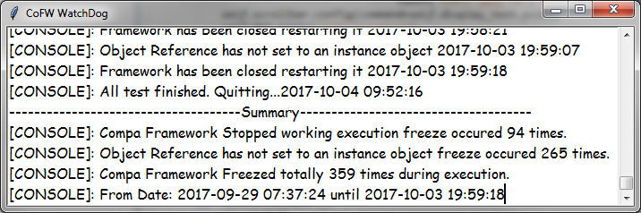
Figure 6. Summary Logger Feature

Instrument Initialization has been done by writing a batch script with parameters
In earlier version instrument initialization performed by clicking on a screen. Fortunately better and faster solution has been found. The CoFW Wathcdog now sending parameters or running CMD file depending os using ISC or Compa Framework.

PyAutoGUI typewriter bug handled
PyautoGUI feature typewrite is used for writing the input testlist parameter to an entry widget. Anyway when writing escape or special characters could result bad format because keyboard is specific to your country and In PyAutoGUI keyboard code is defined in US standard. The bug has been handled by splitting words in a list excluding ‘\’(backslash) and iterating through a list between elements program presses backslash button and modifier what could be defined in the configuration.xml file.

Reworked it to work without problems with ISC & Compa Framework
Differences between running Test on ISC OR Compa Framework is the Cmd file and the error messages what Welcome you when starting it.User have to set the flags in Configuration.xml on the other hand The test list Sample the PATH and so on.

Installer Available
Installer is available thanks for the CX_Freeze module. Executable is a great option because user don’t need to install third party libraries and Development Tools. If creaing executable for source is required please start setup.py with the following command: python setup.py bdist_msi.

Make it Fully Portable and Configurable
Thanks for the installer and the XML for parsing parameter this tool is portable and customizable.

Not Implemented but planned features

Recursive Rerunner Feature
This FEAUTRE IS NOT IMPLEMENTED. Because there was much more important feature to implement to be able finish the tests and not risking the deadlines. Anyway to achieve this the following process is required to achieve this:
1. Check if all True ,If All True: Congratulations
2. If not recheck for duplicate test cases
3. if found duplicate test cases quit
4. if no duplicates Delete All failed & Quit from Framework

Develop more smart picture recognition
Not implemented and its not required anymore. Automating process starts only if the required elements are available.

Not Planned but Implemented features

Handle Exceptions Object Reference not set to an instance of object

This exception is handled by template matching. When this occurs the process is alive but the test is halted exiting from the CoFW is required.

